NYC TAXI - Data Modeling Documentation

Dimensions:
- Service_type_dim
- Date_dim
- Zone_dim
- Payment_type_dim
- Vendor_dim
- Ratecode_dim
- Trip_type_dim
- Hvfhv_base_dim
- Time_dim
- Platform_dim
Facts:
- Trip fact - Dashboard #1
- Revenue Fact - Dashboard #2
- Hvfhv fact - Dashboard #3
- Zone Fact - Dashboard #4

Grain of each dashboard
- #1 —> trip level
- #2 —-> trip level
- #3 —-> trip level
- #4 —-> Zone Level

Bus Matrix

 | Date dim | Service dim | Zone dim | Payment dim | Vendor dim | Ratecode dim | trip type dim | Hvfhv base dim | Time dim | Platform dim
Trip fact | Y | Y | Y | N | Y | Y | Y | N | Y | N
Revenue fact | Y | Y | N | Y | N | N | N | N | N | Y
Hvfhv fact | Y | Y | Y | N | N | N | N | Y | N | Y
Zone fact | Y | Y | Y | N | N | N | N | N | Y | N
NYC TAXI - ERD Diagram

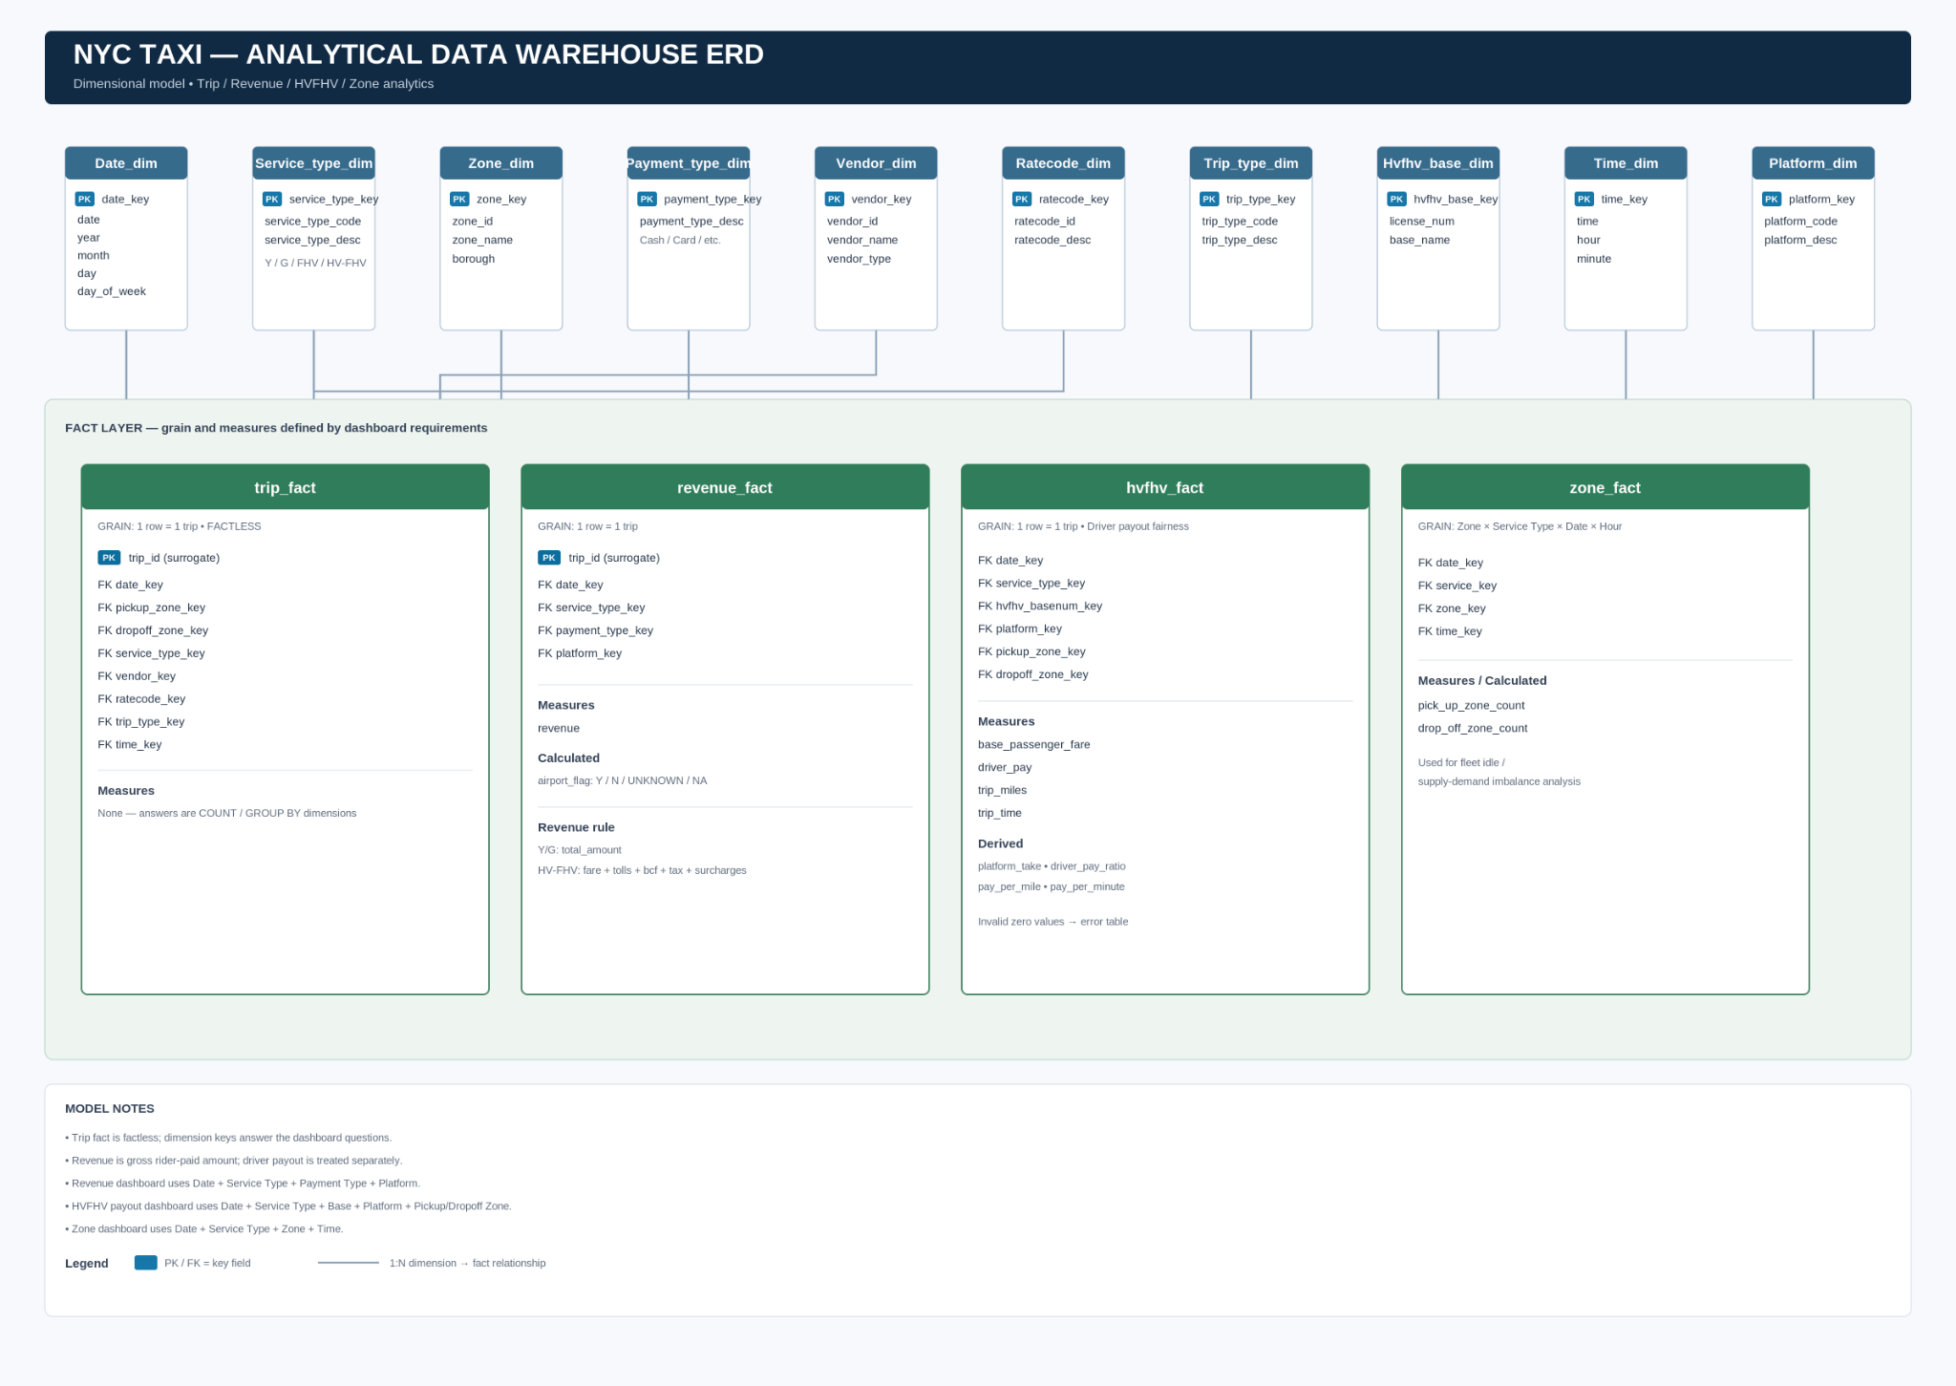

Fact — #1 Trip Fact

It’s seems like it’s factless table which all info needed for this dashboard are stand away out of the measures,
Dim Keys alone are able to answer the questions of the dashboard

Surrogate Key’s:
- Trip id - can be auto generated key (optional) can i add or not

FK’s:
- Date_key
- Pick_up_key
- drop_off_key
- Service_type_key
- Vendor_key
- Ratecode_key
- Trip_type_key
- time_key

Trip Fact is locked:
- Grain: one row = one trip (Yellow/Green/FHV all contribute; HV-FHV too, with vendor/ratecode/trip_type agreed values documented below in the table since those fields don't exist for it)
- Factless — no stored measures, dashboard answers come from counting/grouping by dimension keys
- Keys: trip_id (surrogate PK), date_key, pickup_zone_key, dropoff_zone_key, service_type_key, vendor_key, ratecode_key, trip_type_key, time_key

Record Sample:

trip _id | date_key | pick_up | drop_off | service_type | vendor_key | ratecode_key | trip_type_key | time_key
SEQ | DATE | LOC | LOC | Y/G/H/HV | 1,2,6,7,0(H,HV) | 1,2,3,4,5,6,99,100(H,HV) | 1,2,0(Y,H,HV) | time

Fact — #2 Revenue Fact
what I actually want to see as "revenue."?
Revenue = the total amount the rider paid for the trip. Not what the driver kept, not what the platform kept after paying the driver — the full gross amount that moved through the system when someone paid for a ride. Why I want it this way: this dashboard is about understanding the size and health of the business — how much money is flowing through each service type, month over month. What happens to that money afterward (driver's cut vs. platform's cut) is a completely separate question — that's what Dashboard 3 already covers. I don't want these two dashboards answering the same question twice with different definitions; keep them cleanly separated.
So, concretely:
- Yellow / Green: total_amount — that field is already literally defined by TLC as "the total amount charged to passengers." That's exactly what I mean by revenue. Use it as-is.
- HV-FHV (Uber/Lyft): there's no single total_amount field here — I need you to build the equivalent by summing everything the rider was actually charged: base_passenger_fare + tolls + bcf + sales_tax + congestion_surcharge + airport_fee + tips + cbd_congestion_fee. Notice I'm explicitly NOT subtracting driver_pay — that's an expense/payout, not a reduction in revenue. The ride still generated that much money, regardless of how it got split afterward

Grain Level:
Trip = One row represents the status or revenue of one trip.

Table Fields:

Surrogate Key’s:
- Trip id - can be auto generated key (optional) can i add or not
FK’s:
- date_key
- service_type_key
- payment_type_key
- Platform_key

Calculated:
- Airport Flag
  - Y airport_fee > 0
  - N airport_fee <0
  - UNKNOWN airport = NULL
  - NA service_type refer to GREEN TAXI

Measures:
- Revenue
  - Yellow / Green => total amount
  - HVFHV => base_passenger_fare + tolls + bcf + sales_tax + congestion_surcharge + airport_fee + tips + cbd_congestion_fee.

Record Sample:

trip_id | service_type_key | date_key | payment_type_key | platform_key | airport_flag | revenue
SEQ | Key FK Y,G,HVFHV | DATE | 0-6 Y / G , 7 HVFHV instead of NULL | HV0003 , HV0003,  NA ( G , Y) | Y,N,UNKOWN,NA(Green) | NUM

Fact — #3 Driver Payout Fairness

Grain:
Trip = One row represents the pay of one trip.

FK’s:
- date_key
- service_type_key
- hvhfv_basenum_key
- platform_key
- pick_up_key
- drop_off_key

Measures:
- base_passenger_fare - “ What Passenger Pay)
- driver_pay - “What Driver Take or Earn”
- trip_miles
- trip_time

Calculated:
- platform_take = base_passenger_fare - driver_pay
- driver_pay_ratio = driver_pay / base_passenger_fare
- Pay_per_mile = driver_pay / trip_miles
- Pay_per_minute = driver_pay / (trip_time /60)

Rules:
Rows with
trip_miles = 0, trip_time = 0, or base_passenger_fare = 0
Will forward to the error table.

Fact — #4 Fleet Idle / Supply-Demand Imbalance

Grain:
Zone Level X ServiceType X Date X Hour

One Row = This Zone at this service type level at this date in this time Pickup count was
X and Drop off count was Y

FK’s:

- date_key
- service_key
- zone_key
- time_key

Calculated:
- pick_up_zone_count
- drop_off_zone_count

